# *Synchro Boy* Teacher Guide

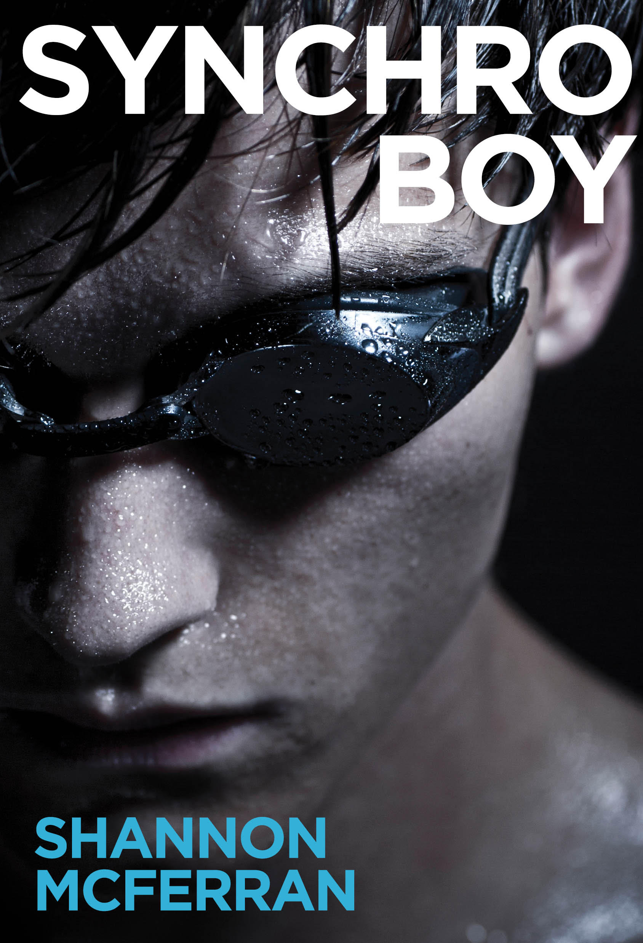

**NOTE:**

**This Teacher’s Guide is a work in progress! Rather than wait until everything is ready, I’m taking an agile approach and sharing this beta release with whole book discussions and project descriptions, as well as a quick overview of the book. Please come back for updated versions of the Guide as I add chapter discussion questions and quizzes, and complete curriculum alignment descriptions.**

This guide contains:

Book Overview: Character, Setting, and Plot overview

Note to the Teacher

Whole book discussion/essay questions

End of Book Activities

Proficiency Scales for Activity Assessment

Chapter discussion questions - TBD

Chapter quizzes - TBD

Quiz answer keys - TBD

BC Curriculum Alignment

Ontario Curriculum Alignment

Common Core English Language Arts 11/12 Standards Alignment - TBD

*Synchro Boy* is an evaluated resource in British Columbia. See the ERAC review of the novel

<https://k12.bcerac.ca/resource/?q=Synchro-Boy&ResourceTitleID=8929>

Synchro Boy has been nominated for a White Pine Award. Visit <http://www.accessola.org/web/OLA/Forest_of_Reading/OLA/Forest_of_Reading/Forest_of_Reading.aspx> for information on how to participate in this exciting reader’s choice award program.

Shannon McFerran may be available for in-person author visits/ writing workshops and Skype/Facetime chats. Contact her at shannon.mcferran@gmail.com.

## Praise for Synchro Boy

“Bart's eventual acceptance that he is bisexual gives him the confidence to lean into synchro while easing off on the need to validate his own masculinity through sporting achievements. A nuanced, compassionate exploration of male   
sexuality and identity.”—*[Kirkus](https://www.kirkusreviews.com/book-reviews/shannon-mcferran/synchro-boy/" \t "_blank)*  
  
Come on in, readers; the water’s fine.

— Michael Cart, *[Booklist](https://www.booklistonline.com/Synchro-Boy-Shannon-McFerran/pid=9703139" \t "_blank)*

4/5 stars - Highly Recommended

“There is a lot to appreciate in Synchro Boy, particularly the fact that, even though there is a “coming out” of sorts, the novel is not in and of itself a coming out story. The considerations of masculinity and femininity and the spaces in between is also refreshing. Anyone who has struggled to exist as feminine or masculine outside of traditionally prescribed assumptions in society will respect Bart’s journey and find much to sympathize with. Synchro Boy would certainly be worth including in classroom or school libraries.“ — Dr. Rob Bittner,*[Canadian Review of Materials](https://www.cmreviews.ca/node/120" \t "_blank)*

"This novel has a strong, fully developed male protagonist. Teens who are struggling with their sense of identity and family issues will relate to the burgeoning romances and the drawn-out emotional conflict between Bart and his father. The secondary characters are less fleshed out than Bart and Erika, but young people will still want to pick up the book.   
VERDICT: An excellent addition to YA shelves."

*[School Library Journal](https://www.slj.com/?reviewDetail=synchro-boy" \t "_blank)*

## Book Overview

### Characters

**Protagonist: Bart Lively: 16**

**Rosa Waves Swim Team:**

Coach Dennis Cragg

Riley Fletcher: Bart’s best friend

Andy

Geoff

**Rosa Pacific Synchro Club:**

Coach: Su-Yun (Sunny) Zhang

Erika Tenaka: Bart’s duet partner

Chelsea Gates: Erika’s former duet partner

Julia Sanford

Kyoka Shiozaki

Casey Bryant

Huiyan Jang

**Others:**

Melanie Lively: Bart’s Mom

Mike Lively: Bart’s Dad

Amanda Gates – Chelsea’s Mom

Ms. Shiozaki – Kyoka’s Mom

Dave Crawley aka “Dive Boy” – fellow student and a Dive Club member

Bill May: Bart’s hero, USA competitive synchronized swimmer, barred from the Olympics in 2004 due to his gender. May was a gold medalist at the inaugural Mixed Duet competition at the FINA World Championships, 2015.

### A Note About Setting

Synchro Boy takes place in a real place, on the traditional territory of the W̱SÁNEĆ, Lekwungen and Songhees Peoples. The characters live in the city of Victoria, on Vancouver Island, British Columbia. The pool and clubs that swim there in the story, however, are fictional—as is Rosa Pacific Secondary School.

The Rosa Waves Synchro club goes to Richmond, BC for a competition, and to Quebec City for the national event. But most of the action takes place at the Rosa Pacific Swimming Pool, Bart’s home, and his school.

### Plot Synopsis

BART LIVELY, a sixteen year old racing swimmer bound for the Olympics, desperately wants to feel like himself again. He loves the water, but he sure misses the freedom and expression he enjoyed when he was a dancer, and felt at home in his skin. He decides to try a free synchro session in the next pool, and it’s more than fun—it’s a challenge that captures him body and soul—*and* there’s a routine for guys: the mixed duet, just included in international competition last year.

ERIKA TENAKA, one of the club’s star swimmers, wants him to practice a mixed duet with her. But Bart’s already fighting off the guys on his team who harass Bart for being gay—something even *he’s* not sure of. If he joined *synchro*, it would only get worse. So Bart refuses, but when he finds out about the men who are fighting the sport’s gender stereotyping to compete in mixed duets around the world and get the event included in the 2020 Olympics, Bart feels compelled to join Erika.

To get the mixed duet ready for the ladder of competition ahead of them, Bart must master the technical aspects of synchro. He’s also falling for Erika, but he can’t seem to shake this ongoing flirtation with a guy in the dive club. And now, Erika’s jealous former duet partner CHELSEA wants Bart out of the club, until she realizes the attention the pair will get for entering the new event—attention she wants for herself. After passing a figures test and swimming at the Provincial competition, Bart gets together with Erika, spending romantic mornings hiding out at the top of the dive tower.

Then his coach splits Bart’s training time between Erika and Chelsea. Bart’s synchro improves with Chelsea’s technical influence, but they get a little too comfortable with each other, and end up kissing after a practice. Bart instantly regrets his slip—even before Erika sees, and refuses to swim her duet with him at the Qualifier. Devastated, Bart swims with Chelsea at the Qualifier. But none of the other mixed pairs show up, so they win by default, and the event is cancelled for the National competition. Tired of trying to master synchro the way Chelsea does—all perfectionism and no joy—Bart turns down her offer to come train with her as she gets ready for the Junior Worlds.

Tired too of trying to master his sexuality, Bart returns home and finally makes out with the boy from the dive club. But he isn’t in love with him—and while Bart knows he could love a guy in the future, he loves Erika in the *now*. So he tells her, and tries to convince Erika to swim with him again, hoping to feel the same joy he did before he started his quest for perfection. She says she’s retiring, but Bart’s secretly sent video of their performances to the federation that runs international competitions, who invites them to demo the mixed duet at the Western Open.

Bart begs Erika to take advantage of the opportunity. Up on the dive tower, he faces his fear of heights to prove that he’ll do anything to be her partner and work toward their Olympic dream together. Erika admits she’s scared about what lies ahead, but that she wants it too—and they leap off the tower together, side by side.

Swimming at the Western Open, they switch the boost so Erika lifts Bart for their big highlight—flipping the gender stereotype on its head, to loud applause from the stands. In the end, Bart knows he’s right where he should be: showing the world there’s more than one way to be a boy.

## Note to the Teacher:

Thank you for your interest in reading *Synchro Boy* with your students! If you have feedback on this resource or a request for a change or addition to the guide, please direct your message to shannon.mcferran@gmail.com.

**A note about First Peoples representation**

Synchro Boy reflects the diversity seen in real clubs and competition in British Columbia during the mid 2010s. There is racial diversity, yet none of the characters in the novel are Indigenous. This may spark a discussion with your students about what this says about access to sport for Indigenous youth, or preferences that Indigenous youth have for types of activities outside of school.

## *Synchro Boy* Whole Book Discussion/Essay Questions

What is the main source of conflict in Synchro Boy? How does it interact with secondary conflicts? How does Bart resolve his internal conflicts through the external action in the story?

Does every choice Bart make (for good or bad) create what happens next in his story? Are there places when it doesn’t?

What is Bart Lively’s biggest fear? What is Chelsea’s? What is Erika’s? How do their fears interact with each other to create interpersonal conflict?

What statement is the author making about gender in sport?

How do Bart’s two coaches – from racing and synchro – view Bart’s role as a male swimmer in these two sports?

Over the course of the book, Chelsea Gates changes for the better. What were the events that led to her transformation?

Some of the characters struggle with perfectionism. How does perfectionism act as an obstacle for the characters? How does it drive action in the story?

Bart is inspired by a real-life hero. How does Bill May give Bart the confidence to pursue his dream and make room for himself in the sport?

Erika says, “I know you’re happiest when you’re not fighting anyone’s idea of who you are …” When is Bart fighting other peoples’ ideas about him? Cite specific examples. How does this hold Bart back from accepting himself?

Is Synchro Boy a coming out novel, or is it pointedly **not** a coming out story? Cite textual evidence to support your view.

## *Synchro Boy* End of Book Activities

**Another Point of View**

Synchro Boy is written from Bart’s perspective, using first person point-of-view. Try writing a scene from the novel in Erika’s or another character’s point of view. You can vary the point of view of the narration as well as the point of view character – Synchro Boy is written in first person. You can try writing your scene from second or third person limited or omniscient.

When you’ve drafted your scene, consider: whose point of view do you like best, and why? If you changed the POV of the narration, did you like yours better, or the 1st person narration of the novel? Consider the reasons for your preference.

**Performance Inquiry (Cross-curricular: Drama and English Language Arts)**

Look for artistic swimming clubs in your area, and find out when they are putting on a watershow. Propose an inquiry to pursue as you watch a performance of artistic swimming. You may choose to describe the connection of audience to performer and the performers to each other. Does watching the event in person make any of the descriptions of synchro or Bart’s feelings about the sport more alive? in writing, reflect on what you wondered before the event, and what you felt about it after.

**Land Drill Routine (Cross-curricular: Drama and English Language Arts)**

Choreograph your own land routine – researching the arm movements used to represent different synchro figures and transitions. Choose music with an 8-count beat, and perform your land drill to your chosen music for your peers. After, write an explanation of the significance of your choice in music and movements, and how the two interact.

**Personal Essay (Composition - writing processes,**

Write a personal essay on one of the topics that play an important role in *Synchro Boy*. Personal essays take a journey that follow your inquiry into a topic, weaving your own thoughts, experiences and memories together with facts and history, often resulting in some truth or insight, and further questions.

* Having our sexuality assumed by others based on our interests
* Macho sports culture
* Acceptance of gender expression
* Men in Synchro – (Biography of Bill May, and other sport pioneers)
* Connecting with mentors in a fight for change
* Another compelling topic of your choice (Propose to your teacher first.)

**Pool Inspiration Poem or Flash Fiction (Creative Writing)**

Begin with a timed writing activity. Set a timer for five minutes, and quickly write a list of as many words to do with pools and swimming as you can. When the timer goes, stop writing. Then go through your list and highlight or underline the words that stand out for you most. Write a lyric using these words—it doesn’t have to be about pools or swimming, but you’re just using those words to spark ideas. Your poem may be about another topic, but use swimming or swimming pools as a metaphor.

Alternatively, use the same list activity to gather words that you use in a flash fiction piece – a very short story with a beginning, middle, and an end. Aim for no more than 250 words.

**Text Dialogue (Creative Writing/Literary Studies/New Media/Visual Art)**

*Synchro Boy* includes several text message exchanges between characters, and some tweets. What choices did the graphic designer make for these conversations? How did the visual presentation effect you reading?

How is text conversation different from dialogue? Consider the different ways in which text dialogue could be presented in different literary forms. How would you present a text exchange within a poem? A play – how could you present the text differently from the dialogue in a script to indicate what needs to happen on stage? How might you present text dialogue inside a mixed media visual art piece? A digital art piece?

## Proficiency Scales for Activity Assessment

Coming soon!

## Chapter Discussion Questions

**Chapter One**

What is Bart’s view of himself as his stands on the bulkhead at the opening of the novel? How does his self-regard present a conflict to be explored in the story?

How is the setting introduced in the novel? How does it provide a stage for the story conflict?

Do you think Bart’s suspension is justified? Why or why not? If you think it wasn’t, how do you think his coach should have handled the conflict?

Geoff calls synchro swimming “water ballet.” Why?

(Chapter Discussion Questions for the remainder of the book Coming soon!)

## Chapter Comprehension Check Quiz

**Chapter One**

1. What does Bart need to do in the relay to make his goal of swimming in a national competition?

2. Why does Bart think Geoff is mad at him?

3. Why doesn’t Bart get his time?

4. How does Bart find himself crossing the tiles between the pools to the synchro pool?

(Chapter Comprehension Check Quiz Questions for the remainder of the book Coming soon!)

## Chapter Quiz Answer Keys

1. Bart needs his triple-A time

2. Bart got faster than Geoff last year.

3. The timer spilled her coffee at the moment Bart reached the end of the lane, when Geoff bumped the table on purpose.

4. Geoff pressured him. Bart wanted to prove he can do whatever he wants, even if that’s trying synchro.

(Remainder of Chapters Coming soon.)

## BC Curriculum Alignment:

To come!

**Literary Studies 11**

**English 12**

Big Idea:

The exploration of text and story deepens our understanding of diverse, complex ideas about identity, others, and the world.

Curricular Competencies

Create and Communicate

* Respond to text in personal, creative, and critical ways

## Ontario Curriculum Alignment

To come!

## USA - English Language Common Core 11/12 Standards Alignment - TBD

To come!